TOPIC 2: PLACES AND BUILDINGS
SPEAKING QUESTION SAMPLES

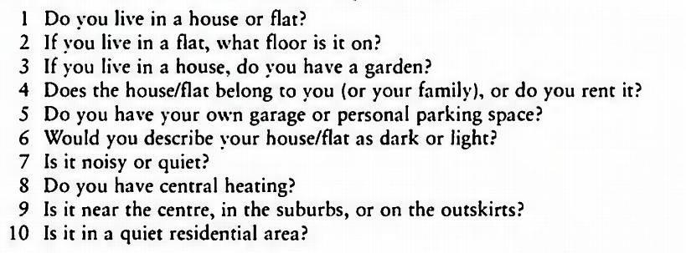
11. Do you like the place where you are living? Why or why not?
12. What is your favorite room in your house? Why?

